Road DISTRACTION SIMULATOR
Hull University DCS

project Plan
For LOCAL humberside school

Table of Contents
1. Executive Summary 2
2. Nature of Business 2
3. Product 3
3.1. Game Concept 3
3.2. Game Overview 3
3.3. Concept Visual Sketches 3
3.4. Learning Elements & Outcomes 4
3.5. Game Features 4
3.6. Gameplay Mechanics 4
3.6.1. Interface 5
4. Techical Aspects 5
4.1. Technical Requirements 5
5. Market and Competitors 6
5.1. Games Industry Market 6
5.2. Our Market 7
5.3. Future Survival Plan 7
5.4. Our Competitors 8
6. Marketing Plan 8
7. Operation 9
8. Financial Analysis 9
8.1. Personnel and Business Costs 9
9. Financial Forecasts 11
10. Legal Issues (IPR) 11
11. Bibliography 12
12. Appendices 13
12.1. Task Plan 13
12.2. Time Plan and Gantt Chart 14

Word count 3158, excluding contents, headings and references.
GAME PROPOSAL AND
Marketing Plan
road distraction simulator

Executive Summary
We are working on behalf of SEED and the University of Hull they have been contracted by a local school to produce a game that can record drivers braking reaction times with distractions. We currently have two clients that have expressed interest in the software:
- Science teacher at local school (brief requirements defined; limited technical knowledge)
- Safer Roads Humber (expressed interest; cost depending)
The two clients have slightly different needs so we must add additional features to ‘tie-in’ the needs of Safer Roads Humber who have described they want a ‘Road Distraction Simulator’.

Nature of Business
Although we have no past experience in similar projects we have the support network and skills to do so. We are working in a small programming team of six third year Computer Science students. Each student will have different areas of expertise according to what modules or degree course they are taking.
Hierarchal organization chart of roles in team:
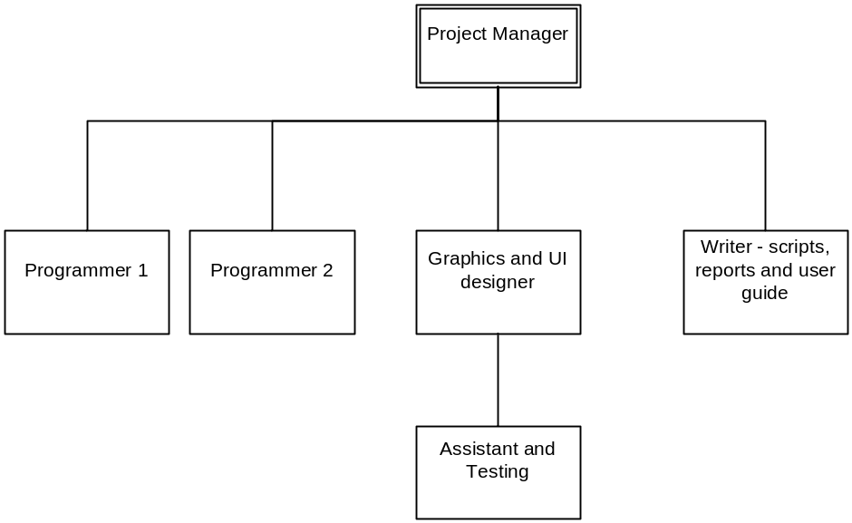
Project roles will be allocated according to ability; the project manager will oversee the project, ensure deadlines are met and arrange weekly progress meetings.

Product

Game Concept
The game is an educational realistic driving simulator aimed at a young audience which raises awareness of distractions on the road and how they impact braking reaction time. The game will collect information from playback to easily show the effects of each distraction.

Game Overview
The title for our game is Road Distraction Simulator its purpose is education, raise awareness and produce statistics it is a driving simulator that will run on the XNA platform to allow compatibility with the Xbox 360 steering wheel device. We are aiming the game for use at local schools initially however additional features may see it being targeted at a different audience.
The game is a turn based game where each turn constitutes a session involving multiple hazard scenarios. The player’s point of view is looking at from within the vehicle dashboard at all times. The goal of the game is to recognize where accidents are likely to occur and learn that distractions behind the wheel are seriously dangerous.
The location of the game is based upon real life footage from the Humber region; however the ability to customize the game and replace footage will be investigated. The game is structured into user sessions where the player must drive to destinations without causing an accident. The direction of the car and each hazard will likely occur in linear sequence. Each player will be given one chance if an accident occurs then their turn is up.

Concept Visual Sketches

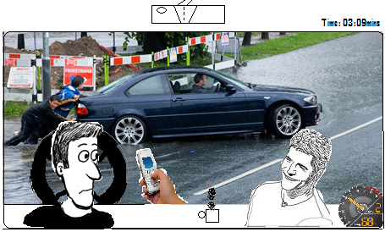

Learning Elements & Outcomes
The intrinsic learning outcomes are to raise awareness of road safety to emphasize the danger of distractions behind the wheel. The player will learn ‘good driving’ habits because unlike the majority of driving games there is a negative consequence of crashing. The player will strive to drive without crashing despite distractions this will test their concentration levels and make them aware that driving is a task that involves your full concentration.

Game Features
- Educational turn based driving simulator
- Visual distractions include muffins on dashboard, fluffy dice hanging from rear view mirror, hot air balloons from outside, hitchhikers with signs & large billboards
- Audio distractions include music, talking, radio static & outside sirens
- Customizable realistic locations
- Spreadsheet will be generated providing the vital time information you need
- Compare your results with your friends

Gameplay Mechanics
The user picks a character and chooses their name now they have a driver the car starts off stationary then is given a task to drive towards a destination i.e. local school. Multiple potential hazards occur along the way forcing the driver to brake for example: pedestrian crossings, red lights, children playing ball in the road and parked vehicles pulling out.
Whilst coping with these hazards audio and visual distractions occur. As the game progresses more distractions occur at the same time. The user will become aware at how difficult it can be to cope with distractions when on the road and how important it is to be fully aware.
The teacher will be able to display the times for each driver it took to brake and compare each distraction, this will show the teacher the worst distractions.
Use case diagram of the system:
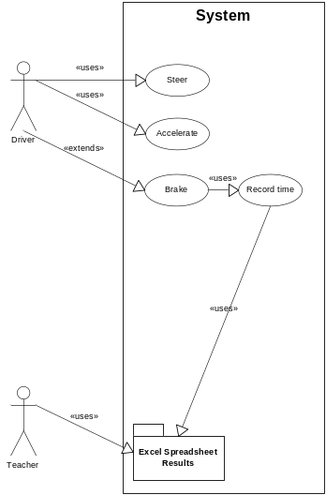

Interface
- Control devices: Xbox 360 wireless steering wheel and pedals
- Navigation: Display out windscreen, user selection with steering wheel and pedal
- Locomotion: Acceleration pedal moves car forward in direction of road, brake halts the car & steering wheel direction determines direction of the vehicle.
- Display: Will be a dashboard with multiple dials including speed, warnings, rear view mirror & widescreen

Techical Aspects
The simulator will be designed in XNA using C# as the language it will need either a PC running Microsoft .NET to run or may be ported to the Xbox 360. We will be using one input device the Xbox 360 wireless steering wheel and pedals these will provide the users interaction with the simulator.
Because of the limited timeframe we will make use of the driving XNA starter kit to produce the basic mechanics of a driving game this template will be modified to meet our requirements.
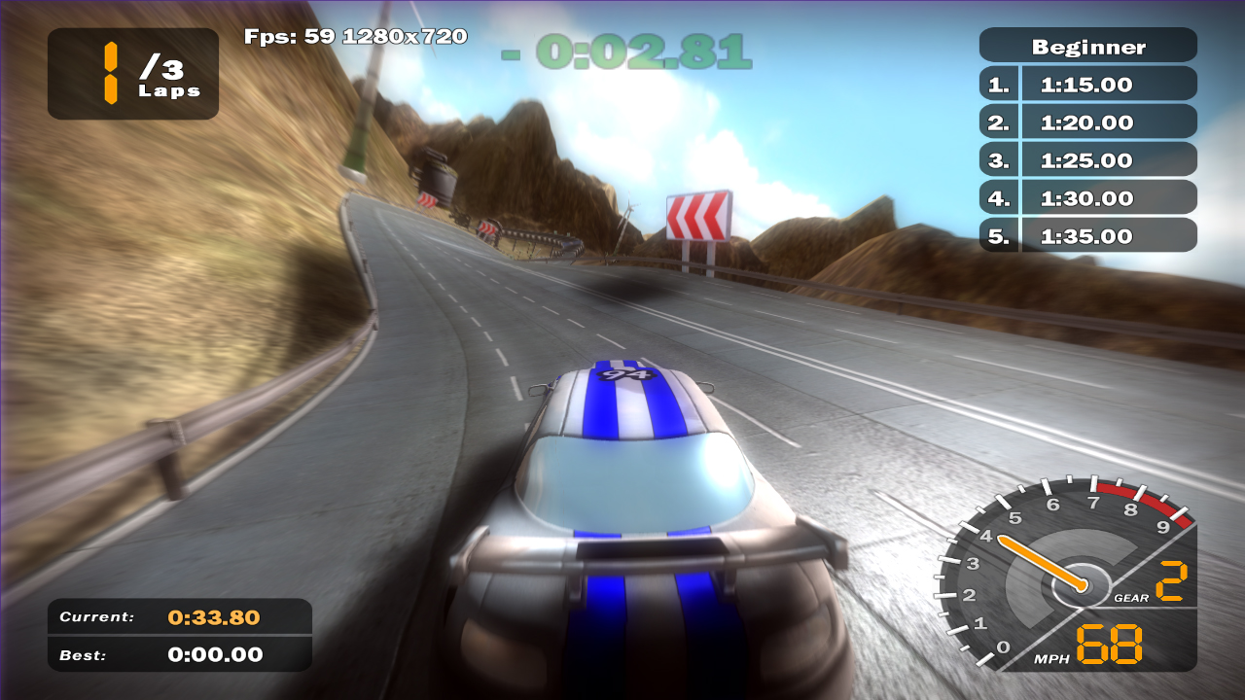
(XNA Creators Club, 2007, Racing Game)

Technical Requirements
- Steering wheel changes the position of the car which the display method will be updating
- Brake pedal triggers the event to stop the timer and record the time
- Spreadsheet will be used to store reaction times and comparison of times between use of distractions saved on closure of the game
- The 10 lowest reaction times will be recorded and drivers awarded a good driver award
- One game 3 minute session per user encompassing all different distractions
Flowchart below showing simple game structure:
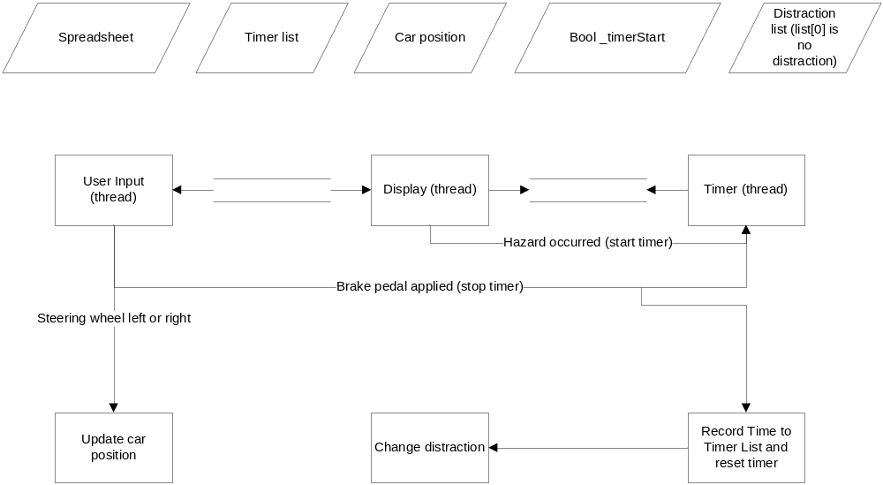

Market and Competitors

Games Industry Market
The general consensus is that PC based software unit sales and profits in the UK are falling, despite the console game market’s resilience with the release of the latest generation of consoles it proving to be recession proof. The PC software market has declined for multiple reasons:
- Fewer long term software contracts with businesses
- Cost cutting strategies in non-ICT businesses usually translates to cuts in non-vital sectors such as software upgrades or new software projects
- Open source and free software becoming more professional
- Consumer net book explosion has driven the downloadable free open source software expansion
For example, data from the Entertainment software association announced in January 2009 showed that global PC game revenue had dropped by 23 percent over 2008.
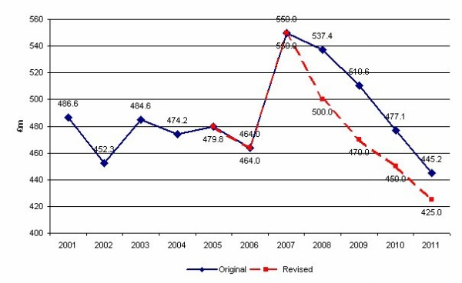
(Mintel, 2009, Market Re-forecasts Technology UK)

Our Market
We currently have access to all the school in the entire region through the 4 road safety advocates within the fire service working for our client in Safer Roads Humber this could produce a viable income and a great break into the seemingly unexplored road safety software market in this region.
Nationally road safety has always been a concern on the roads of Britain; our software helps us understand exactly what impact distractions have on a driver reaction time. There is a demand for two types of software in this sector:
- Training software – help individuals in education or driving tests
- Statistic production – help provide knowledge to government on road safety
Training software such as the hazard perception test exists could be improved upon by adding distractions for drivers to cope with however the hazard perception test is produced in-house by the DVLA, perhaps they require a training program for disqualified drivers and we could present a case and hopefully win a contract.
Recently mobile phones had been statistically proved to cause accidents and have now been banned whilst driving and a large advertising campaign costing millions was launched to make people aware of this, perhaps another distraction on the roads could be identified early and information could be sold to the government.

Future Survival Plan
The fact the PC software market is shrinking increases the possibility of expansion into the console sector would have to be considered for either the future of this project or other future projects. We are designing the software in XNA so moving the software to the Xbox 360 would be simple and allow expansion to that sector.
Our market seems to be the exception to this overall dim outlook for PC software as we are developing the product for a local school we have no known competitors for either of our clients and we have the contract to start development straightaway.
Possible future expansion after the product succeeds in the Humber region it could be sold to the Highways Agency, approved as a learning tool by the education body and/or interestingly it could be modified to meet the requirements for a part of the DVLA retraining schemes for disqualified drivers.

Our Competitors
The majority of our competitors will be companies already contracted to government agencies or in-house development such as exists in the DVLA. In order to break these barriers to entry we need to develop a track history first and sell a unique product.
Internationally there is web based software highly similar to what we are producing designed to raise awareness of distractions on the road it is made by the Insurance Bureau of Canada however this is web based and designed to raise awareness without producing statistics or data.
Screenshot of similar online based game below:
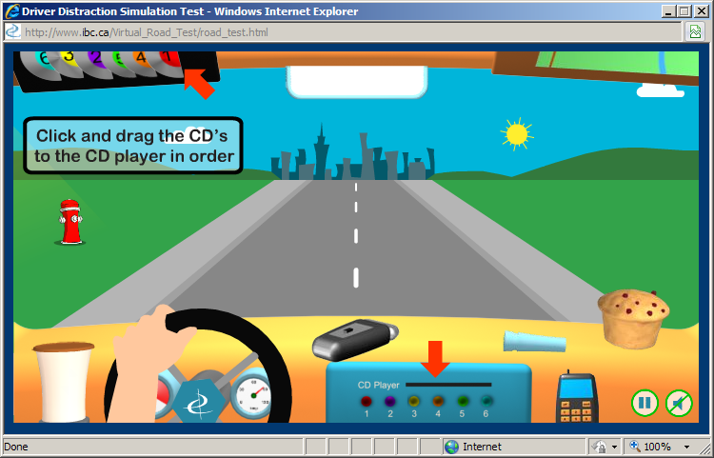
(Insurance Bureau Canada, 2009, Avoiding Driver Distractions)

Marketing Plan
The market segment we are targeting are local authorities, the users for the game will be a young varied selection of secondary school students most will have experience in video games and will be able to use the familiar steering wheel and pedal to play the simulator.
We could make use of our research into our target audience by including in-game advertisements in our simulator that specifically target this young audience. The sponsorship benefits we will receive will decrease the gap needed to make this venture profitable. However such advertisements should:
- Not affect the operation of the simulator
- Be relevant to the scenario (i.e. car manufacturer, petrol station or law firm)
We will be analyzing the market in both the public sector of the UK & road safety schemes eventfully will be analyzing the technology behind the simulator and suitably updating it with market trends. Our research will be from numerous sources desk research will be supported by Mintel reports and our field research includes feedback from clients and students participating in the use of the simulator.
Since the product is not going to be sold through standard distribution channels and to government channels instead the marketing campaign will rely on:
- Repeat business
- Direct contact
- Word of mouth (contacts)
- Leaflet and letters to relevant government bodies/unions i.e. Highways Agency, NUT
In the event relations with the education board break down, our backup marketing policy is to market the simulator directly to the teachers through the above methods.

Operation
We will be working in a team environment with use of the University facilities. Initial design and development starts early, and as majority of the first internal deliverables are set within the first 3 weeks this will expose any troubled team members early on causing less problems later.
During group meetings all information and progress will be shared to ensure there won’t be delays e.g. simply because one coder doesn’t know how to interface with another coders method or data. Method placeholders and class diagrams will be designed before the code is developed and the user interface is drawn on paper first.

Financial Analysis
Normally funding for a game's development comes from either: internal resources, third party finance providers, the publishers and less commonly the distributors of the game. Unusually our budget and finance for the project is supported by SEED and the University of Hull as they are providing the computing resources in the labs, software licensing for the project & the personnel who will be an organised group of third year Computer Science students from different disciples.
Both of our clients have limited resources and have expressed concern over cost, so conservative estimate based on what local government normally pays for a small Software Project we expect £500 for the school teacher client and between £2000-£4000 from our client at Safer Roads Humber. These figures would make a commercial venture involving just these two clients simply not feasible due to development costs. To become a commercially viable we must find a way to accommodate other client’s requirements for similar projects.
The income generated from the two projects is not as important as the praise and positive feedback that should filter to other teachers and the Highways Agency for future projects and therefore we will endeavour to complete the project to the highest standard.

Personnel and Business Costs
Given the average permanent software developer in the UK is paid £35,000 we believe due to the lower living costs of Hull compared to say London we can safely undercut this salary to £26,000.
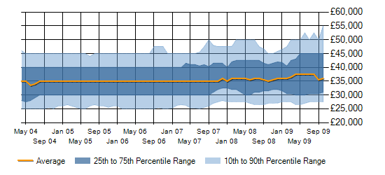
Demand is dropping for Software Engineers in the UK partly due to the recession so starting the project now could mean lower personnel costs and a higher profit for the project.
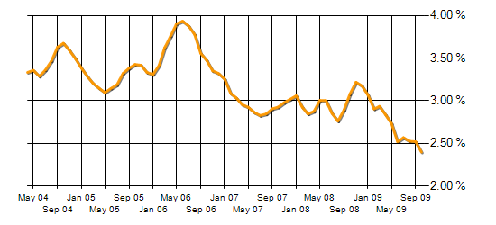
(ITJobsWatch, Software Engineering Employment Trends)
Staff Position | Personnel costs (tax inclusive) based on a 6 week contract
Project manager x1 | £6,000
Experienced programmer x2 | £10,000
Graphics design and UI developer x1 | £3500
Accountant/writer x1 | £4500  Total cost £24,000

Business Cost Description | Cost based on 6 week contract
Software licensing costs | Licenses usually start from 12 months minimum:  £4000 (however the software license can be used in future projects)
Recruitment costs | £50
Corporate taxation | Possible exemption due to being small starting business likely to be eligible for a government grant of approximately £400.  (Business Link, 2009 Grants and Government Support UK)
Rent | £600 (6 weeks flexible) in offices near Kingswood Retail Park outside Hull.
Bills | Gas and electricity together provided by EON  £350
Cleaning (other support will be carried out by existing staff) | £150 – Sometimes included by the office rent as they can make economies of scale profits with multiple offices.  Total cost (minus grant) £3250

Financial Forecasts
So with development costs considered for this to be a viable project we would require multiple repeat clients and at least a total net income of £30,000 to cover software licensing costs.
Through good contacts with government departments and road safety partnerships we can achieve this goal. Online distribution could provide additional income without paying commission to a retailer, producing packaging/box art or dealing with international transport it would work via user download and registration of the software. As the simulator is being produced in XNA it will be fully compatible with the Xbox 360 and publishing the software for sale as an educational game on Xbox Live Marketplace would also provide additional cash flow.

Legal Issues (IPR)
Our client in ‘Safer Roads Humber’ has told us that he is undertaking a filming car journey project we could use the footage from this project as a resource in our Driving Distraction Simulator however we would have to have further investigate the legal issues with use of this resource. Safer Roads Humber has confirmed that they have commissioned the project, whether they own the rights for the footage and are prepared to allow use within our project is a matter to discuss.
In the vast majority of game development projects publishers will normally seek to control the IPR on titles that they are proposing to fund irrespective of who devised the original game concept or who develops the title. Our client has not brought up the subject of IP ownership of the game. However we as developers expect the University of Hull to either already hold an IPR or pursue one during the project process.
Currently the project contract is limited to local clients who may have access to many schools in the region however if the project ever became international global re-sale rights would have to be obtained.

References
Business Link, Ongoing. Grants and Government Support UK [online]
Avaliable: http://www.businesslink.gov.uk/bdotg/action/layer?topicId=1073866776
[Accessed 21/October/2009]

Insurance Bureau of Canada, 2009. Avoiding Driver Distractions [online]
Avaliable: http://www.ibc.ca/en/BeSmartBeSafe/Road_Safety/Driver_Distraction.asp
[Accessed 10/October/2009]

ITJobsWatch, Ongoing. Software Engineering Employment Trends UK [online]
Avaliable: http://www.itjobswatch.co.uk/jobs/uk/software%20engineer.do
[Accessed 14/October/2009]

Mintel, August 2008. Video and Computer Games UK [online]
Avaliable: http://academic.mintel.com/sinatra/oxygen_academic/search_results/show&/display/id=280418
[Accessed 12/October/2009]

Mintel, March 2009. Market Re-Forecasts – Technology UK [online]
Avaliable: http://academic.mintel.com/sinatra/oxygen_academic/my_reports/display/id=447273&anchor=atom
[Accessed 13/October/2009]

Mintel, August 2009. Gaming in the Interactive World [online]
Avaliable: http://academic.mintel.com/sinatra/oxygen_academic/search_results/show&/display/id=395164
[Accessed 13/October/2009]

Nitschke, B, April 2007. XNA Racing Starter Kit [online]
Avaliable: http://creators.xna.com/en-GB/starterkit/racinggame
[Accessed 26/October/2009]

Bibliography
Miles, R, 2008,
Microsoft XNA Game Studio 2.0: Learn Programming Now
Washington: Microsoft Press

Price, J, 2003
C# Complete
USA: Sybex

Appendices

Task Plan
Tasks organised using iterative waterfall model, all tasks within each stage are run concurrently from the start to the finish of the lifecycle stage unless stated otherwise and milestones are marked with a bold capital M.

Requirements Specification (week 1)
- Organise first project meeting, allocate tasks and outline deadlines [Project Manager]
- Decide constraints on UI [Graphics/UI Designer 1 & 2]
- Consider what classes and data structures are needed [Programmer 1 & 2]
- Write the script and plot pace significant events in game [Writer] M (end)

Design (week 2)
- Design UI on paper [Graphics/UI Designer 1]
- Investigate what trigger events from the UI will call the methods share information with programmers [Graphics/UI Designer 2]
- Construct data structures [Programmer 1]
- Produce method placeholders and class diagrams in Visio [Programmer 2]
- Produce concept designs and progress report [Writer & Project Manager] M (end)

Implementation (weeks 3-5)
- Ensure the tools, version control and backups are in place [Product Manager]
- Record problems, changes, algorithms & meeting minutes [Project Manager]
- Develop the UI statically [Graphics/UI Designer 1]
- Animate and add sound effects to the UI [Graphics/UI Designer 2] M (week 4)
- Develop classes and methods to handle events [Programmer 1]
- Link UI events to call methods in the back-end code [Programmer 2]
- Interface code with data structures [Programmer 2] M (week 4)
- Write help file for simulator [Writer] M (end)
- Integrate UI with back-end [Graphics/UI Designer 1 & 2, Programmers 1 & 2] M (end)

Verification (week 6)
- White-box test each method [Programmer 1 & 2]
- Black box test the simulator [Graphics/UI Designer 1 & 2] M (week 6)
- Write out analysis of algorithms used and problems into a full report [Writer]
- Organise project into deliverable [Project Manager] M (end)

Time Plan and Gantt chart
The major milestones and costs stages for the project (£500 for the whole project) are:
- Produce concept designs and progress report (week 2) £50 client 1
- UI with animation and sound and back end code completed (week 4) £50 client 1
- Working simulator (week 6 - start) £175 client 1
- Deliverable (week 6 - end) £225 client 1
The project is 54 hours of work per role based on 9 hours weekly work it is carried out within 6 consecutive weeks by 6 developers this is achievable with regular meetings and great team communication. Based on the figures we expect per client to pay minimum of £500 from the teacher and £2000 from the client at Safer Roads Humber. We have incorporated costs per stage of the project the client and will see the progress at each payment stage.
Gantt chart below:
